Week 3 — Seller & Inventory Management System
Course: E-Commerce Order Management System
Module: Seller & Inventory Management

OBJECTIVE
Students will design Seller and Inventory tables, connect them to the existing Product database, implement CRUD operations, and write queries to monitor inventory, generate reports, and analyze stock.

SCENARIO
An e-commerce company sells products supplied by multiple sellers. The system must:
- Maintain seller contact and location details.
- Track which sellers supply which products.
- Maintain one inventory record per product (product-level stock).
- Provide queries and reports for availability, low stock, and inventory analysis.

LEARNING OUTCOMES
After completing Week 3, students will be able to:
- Model seller and inventory data and link to an existing Products table.
- Create SQL tables and apply constraints: PK, FK, UNIQUE, NOT NULL, CHECK.
- Implement CRUD operations for sellers, product-seller mapping, and inventory.
- Write queries to monitor stock levels and identify low / out-of-stock items.
- Produce seller-wise and product-wise inventory reports and perform analysis.

ENTITIES & RELATIONSHIPS

Entities
1. Sellers
- Seller_ID (PK)
- Seller_Code (readable unique code, e.g., S101)
- Seller_Name
- Email (UNIQUE)
- Phone
- Address
- Created_At
2. Products (existing table — reference)
- Product_ID (PK)
- Product_Name
- Category_ID, Price, etc. (assumed)
3. Seller_Product (junction table — many-to-many)
- SP_ID (PK)
- Seller_ID (FK → Sellers.Seller_ID)
- Product_ID (FK → Products.Product_ID)
- Supply_Price (optional)
- Active (boolean)
- UNIQUE (Seller_ID, Product_ID)
4. Inventory (one row per product — 1:1)
- Inventory_ID (PK)
- Product_ID (FK → Products.Product_ID) UNIQUE
- Total_Stock (INT, NOT NULL, CHECK >= 0)
- Stock_Status (Available / Out of Stock)
- Last_Updated (DATE)

Relationships
- Sellers —< Seller_Product >— Products (many-to-many via Seller_Product).
- Products — Inventory (1 to 1).
- Seller_Product.Seller_ID → Sellers.Seller_ID
- Seller_Product.Product_ID → Products.Product_ID
- Inventory.Product_ID → Products.Product_ID

TABLE DESIGNS

1. Sellers
CREATE TABLE Sellers (
Seller_ID INT AUTO_INCREMENT PRIMARY KEY,
Seller_Code VARCHAR(10) NOT NULL UNIQUE,
Seller_Name VARCHAR(150) NOT NULL,
Email VARCHAR(150) NOT NULL UNIQUE,
Phone VARCHAR(20) NOT NULL,
Address TEXT,
Created_At DATETIME DEFAULT CURRENT_TIMESTAMP
);
Note: Email is UNIQUE to avoid duplicate seller accounts. Seller_Code is an optional friendly ID such as S101.

2. Seller_Product
CREATE TABLE Seller_Product (
SP_ID INT AUTO_INCREMENT PRIMARY KEY,
Seller_ID INT NOT NULL,
Product_ID INT NOT NULL,
Supply_Price DECIMAL(10,2),
Active BOOLEAN DEFAULT TRUE,
FOREIGN KEY (Seller_ID)
REFERENCES Sellers(Seller_ID),
FOREIGN KEY (Product_ID)
REFERENCES Product(Product_ID)
);
Note: UNIQUE prevents duplicate mappings. ON DELETE CASCADE is optional and should be chosen based on business rules.

3. Inventory
CREATE TABLE Inventory (
Inventory_ID INT AUTO_INCREMENT PRIMARY KEY,
Product_ID INT NOT NULL UNIQUE,
Total_Stock INT NOT NULL DEFAULT 0 CHECK (Total_Stock >= 0),
Stock_Status VARCHAR(20) NOT NULL DEFAULT 'Out of Stock'
CHECK (Stock_Status IN ('Available','Out of Stock')),
Last_Updated DATE NOT NULL DEFAULT (CURRENT_DATE),
FOREIGN KEY (Product_ID)
REFERENCES Product(Product_ID)
);
Note: UNIQUE(Product_ID) enforces the 1:1 mapping. CHECK prevents negative stock.

SAMPLE DATA
Assume the Products table already exists with Product_IDs 201, 202, 203, etc.

Insert Sellers
INSERT INTO Sellers
(Seller_Code, Seller_Name, Email, Phone, Address)
VALUES
('S101','ABC Electronics','abc@electronics.com','9876543210','No.12, Industrial Rd'),
('S102','Fashion World','contact@fashionworld.in','9445566778','12, Market Street'),
('S103','Homeware Hub','sales@homeware.com','9123456780','45, Central Ave');
Seller_ID | Seller_Code | Seller_Name | Email | Phone | Address
1 | S101 | ABC Electronics | abc@electronics.com | 9876543210 | No.12, Industrial Rd
2 | S102 | Fashion World | contact@fashionworld.in | 9445566778 | 12, Market Street
3 | S103 | Homeware Hub | sales@homeware.com | 9123456780 | 45, Central Ave

Map Sellers → Products
INSERT INTO Seller_Product
(Seller_ID, Product_ID, Supply_Price)
VALUES
(1,1,45000.00),
(2,2,1200.00),
(3,4,3500.00),
(1,4,3400.00);
-- Product 203 supplied by two sellers
SP_ID | Seller_ID | Product_ID | Supply_Price | Active
1 | 1 | 1 | 45000.00 | TRUE
2 | 2 | 2 | 1200.00 | TRUE
3 | 3 | 4 | 3500.00 | TRUE
4 | 1 | 4 | 3400.00 | TRUE
Inventory Records
INSERT INTO Inventory
(Product_ID, Total_Stock, Stock_Status, Last_Updated)
VALUES
(1,25,'Available','2026-08-10'),
(2,0,'Out of Stock','2026-08-12'),
(3,8,'Available','2026-08-14');
Inventory_ID | Product_ID | Total_Stock | Stock_Status | Last_Updated
1 | 1 | 25 | Available | 2026-08-10
2 | 2 | 0 | Out of Stock | 2026-08-12
3 | 3 | 8 | Available | 2026-08-14

MAINTAIN SELLER & PRODUCT MAPPINGS — CRUD EXAMPLES

1. Add New Seller
INSERT INTO Sellers
(Seller_Code, Seller_Name, Email, Phone, Address)
VALUES
('S104','Gadget Store','hello@gadgetstore.com','9001122334','88, Tech Park');

2. Assign Product to Seller
INSERT INTO Seller_Product
(Seller_ID, Product_ID, Supply_Price)
VALUES
(4,204,2500.00);

3. Display Products Supplied by Each Seller
SELECT s.Seller_Name, p.Product_ID, p.Product_Name
FROM Sellers s
JOIN Seller_Product sp
ON s.Seller_ID = sp.Seller_ID
JOIN Products p
ON sp.Product_ID = p.Product_ID
ORDER BY s.Seller_Name;

4. Count Products per Seller
SELECT s.Seller_Name,
COUNT(sp.Product_ID) AS Product_Count
FROM Sellers s
LEFT JOIN Seller_Product sp
ON s.Seller_ID = sp.Seller_ID
GROUP BY s.Seller_ID, s.Seller_Name;

5. Update Seller Contact
UPDATE Sellers
SET Email = 'newemail@domain.com',
Phone = '9000000000'
WHERE Seller_ID = 2;

6. Delete Seller
DELETE FROM Sellers
WHERE Seller_ID = 4;
-- Seller_Product entries will be removed
-- if fk_sp_seller is ON DELETE CASCADE

TRACK PRODUCT AVAILABILITY — QUERIES

1. Display All Available Products
SELECT p.Product_ID,
p.Product_Name,
i.Total_Stock
FROM Products p
JOIN Inventory i
ON p.Product_ID = i.Product_ID
WHERE i.Stock_Status = 'Available';

2. Find Products That Are Out of Stock
SELECT p.Product_ID,
p.Product_Name
FROM Products p
JOIN Inventory i
ON p.Product_ID = i.Product_ID
WHERE i.Stock_Status = 'Out of Stock';

3. Identify Products with Stock < 10
SELECT p.Product_ID,
p.Product_Name,
i.Total_Stock
FROM Products p
JOIN Inventory i
ON p.Product_ID = i.Product_ID
WHERE i.Total_Stock < 10;

4. Update Inventory After New Stock Arrival
Example: Add 50 units to product 203.
UPDATE Inventory
SET Total_Stock = Total_Stock + 50,
Stock_Status =
CASE
WHEN Total_Stock + 50 > 0
THEN 'Available'
ELSE 'Out of Stock'
END,
Last_Updated = CURRENT_DATE
WHERE Product_ID = 203;
Important: The CASE above uses the old Total_Stock value. In some RDBMS, you may need to compute using variables or perform the update in two statements to ensure correct evaluation.

5. Remove Discontinued Inventory & Mappings
DELETE FROM Inventory
WHERE Product_ID = 202;
DELETE FROM Seller_Product
WHERE Product_ID = 202;
-- Optionally:
-- DELETE FROM Products WHERE Product_ID = 202;

INVENTORY REPORTS

Report 1 — Seller-wise Product Report
Display seller name, number of products supplied, and available stock.
SELECT s.Seller_Name,
COUNT(sp.Product_ID) AS Products_Supplied,
COALESCE(SUM(i.Total_Stock), 0) AS Available_Stock
FROM Sellers s
LEFT JOIN Seller_Product sp
ON s.Seller_ID = sp.Seller_ID
LEFT JOIN Inventory i
ON sp.Product_ID = i.Product_ID
GROUP BY s.Seller_ID, s.Seller_Name
ORDER BY Available_Stock DESC;

Report 2 — Stock Availability Report
Display product name, stock quantity, stock status, and last updated date.
SELECT p.Product_Name,
i.Total_Stock,
i.Stock_Status,
i.Last_Updated
FROM Products p
JOIN Inventory i
ON p.Product_ID = i.Product_ID
ORDER BY i.Total_Stock DESC;

Report 3 — Inventory Analysis
Analyze:
- Total products available
- Products out of stock
- Highest stocked products
- Average inventory quantity
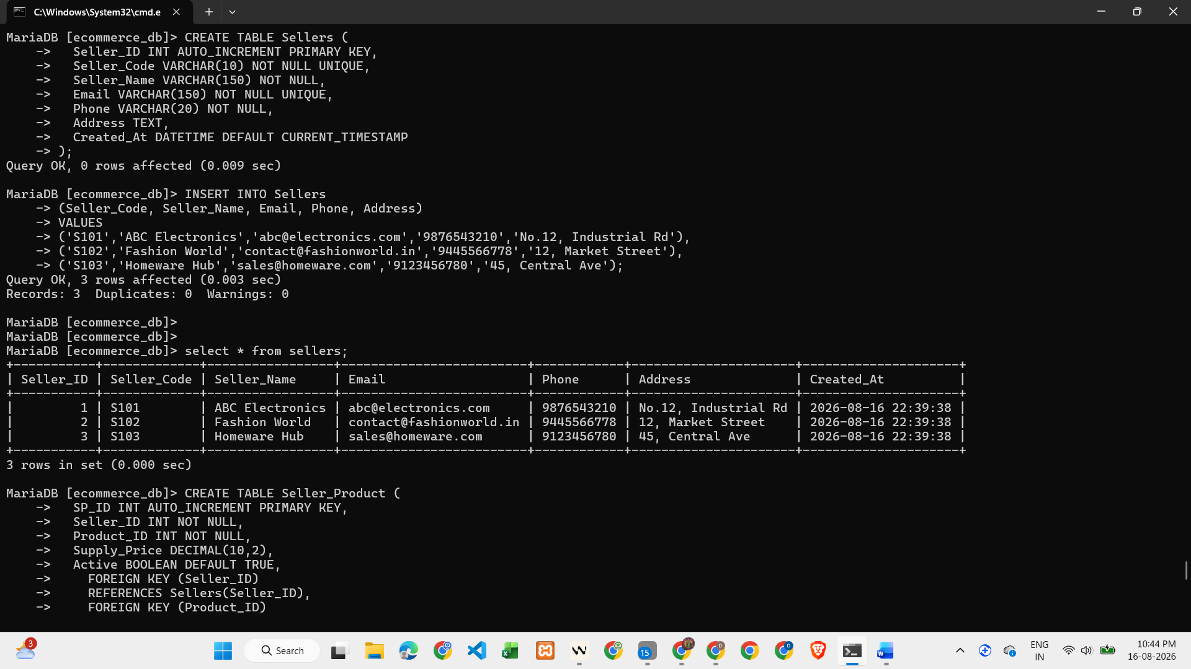
-- Total products with stock > 0
SELECT COUNT(*) AS Total_Products_Available
FROM Inventory
WHERE Total_Stock > 0;
-- Products out of stock
SELECT COUNT(*) AS Out_Of_Stock
FROM Inventory
WHERE Total_Stock = 0;
-- Highest stocked products (top 5)
SELECT p.Product_Name,
i.Total_Stock
FROM Products p
JOIN Inventory i
ON p.Product_ID = i.Product_ID
ORDER BY i.Total_Stock DESC
LIMIT 5;
-- Average inventory quantity
SELECT ROUND(AVG(Total_Stock), 2) AS Avg_Stock
FROM Inventory;

